Worksheet


Items highlighted in yellow are tasks for you to complete
Items in Blue italics are help tips

Graphic Design Y9

Using ink, crayon, pen paint or objects create on small sheets of paper, (half A4) patterns and designs which you can attach a title to i.e. Pour, Dive, Stack, Bounce (you think up the names)

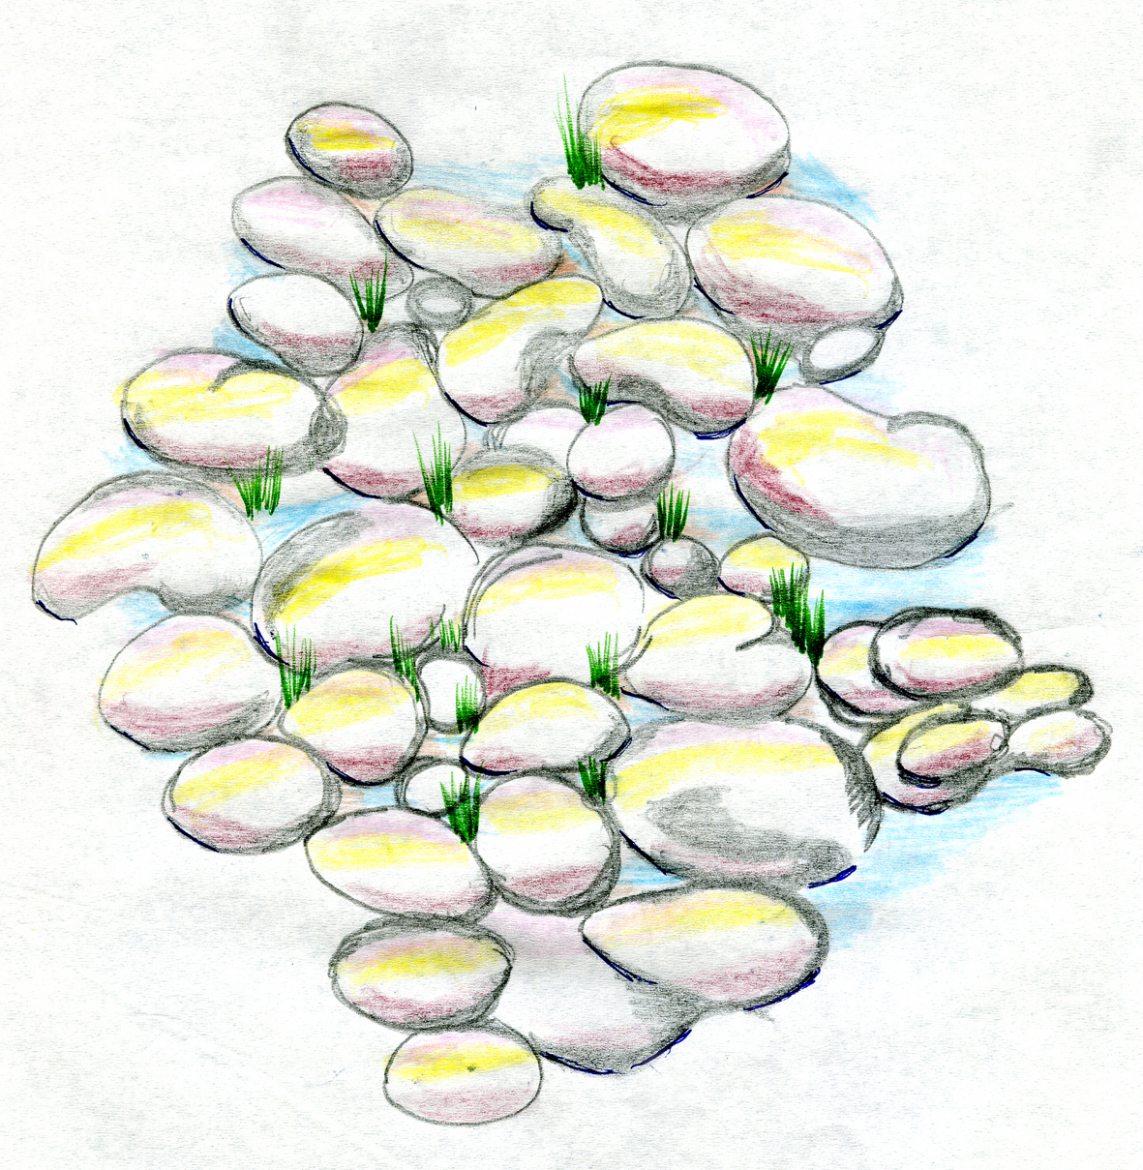Stack

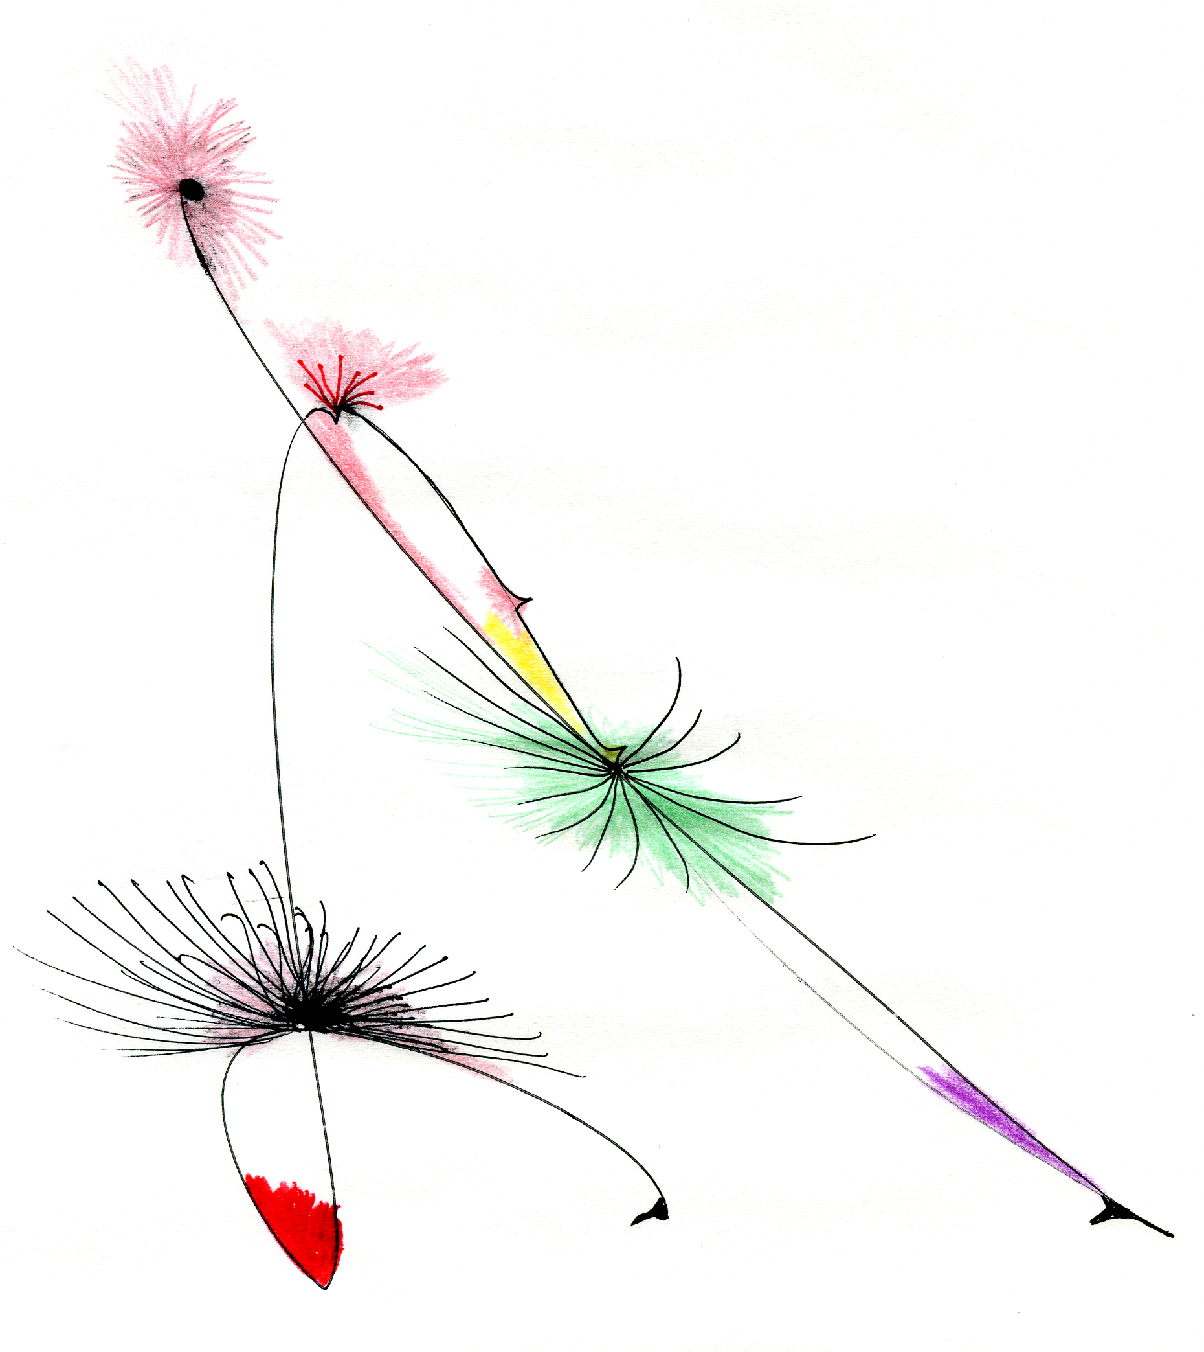Dive

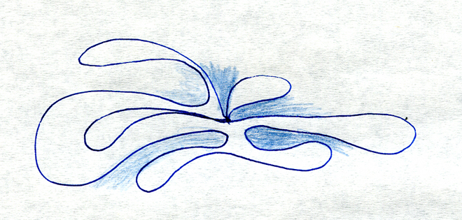 Bounce


Need help just ask

